Task 4 Creating a Prototype User Interface and Usability Testing

**INTI International College Penang School of Engineering and Technology**

**3+0 Bachelor of Science (Hons) in Computer Science, in collaboration with Coventry University, UK**

**3+0 Bachelor of Science (Hons) in Computing, in collaboration with Coventry University, UK**

**Coursework cover sheet**

**Section A - To be completed by the student**

|  |  |
| --- | --- |
| Full Name: Clarence Wee Tze Wen | |
| CU Student ID Number: 12673140 | |
| Semester: 2 | |
| Session:  **April 2022** | |
| Lecturer:  **Nadhrah Abdul Hadi (nadhrah.abdulhadi@newinti.edu.my)** | |
| Module Code and Title:  **4067CEM Software Design** | |
| Assignment No. / Title:  **Continuous Assessment** | % of Module Mark:  **50** |
| Hand out Date:  **22nd April 2022** | Due Date:  **Task 1: 13 May 2022, by 11.59pm**  **Task 2: 1 July 2022, by 11.59pm**  **Task 3: 17 June 2022, by 11.59pm.**  **Task 4: 17 June 2022, by 11.59pm.**  **Task 5: 17 June 2022, by 11.59pm.** |
| Penalties: No late work will be accepted. If you are unable to submit coursework on time due to extenuating circumstances, you may be eligible for an extension. Please consult the lecturer. | |
| Declaration: I/we the undersigned confirm that I/we have read and agree to abide by the University regulations on plagiarism and cheating and Faculty coursework policies and procedures. I/we confirm that this piece of work is my/our own. I/we consent to appropriate storage of our work for plagiarism checking.  Signature(s): ________________________ | |

**Section B - To be completed by the module leader**

|  |  |  |
| --- | --- | --- |
| Intended learning outcomes assessed by this work:  1. Understand and apply appropriate concepts, tools and techniques to each stage of the software development  2. Understand and apply design patterns to software components in developing new software  3. Demonstrate an understanding of project planning and working to agreed deadlines, along with professional, interpersonal skills and effective communication required for software production  5. Demonstrate an awareness of, and ability to apply, social, professional, legal and ethical standards as documented in relevant laws and professional codes of conduct such as that of the Malaysian National Computer Confederation. | | |
| Marking scheme | Max | Mark |
| 1. User Story Mapping 2. Setting up a GitHub Repository 3. Creating a Class diagram and design pattern selection 4. Creating a Prototype User Interface and Usability Testing 5. Discuss the ethical issue related to the software | 20  10  30  20  20 |  |
| Total | 100 |  |

**Event**

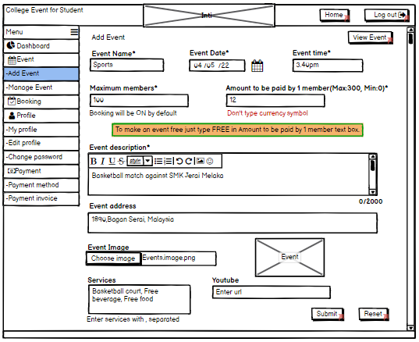

1. This page displays the information required when user want to add new events into the system. Firstly, user must enter the event name, date and time, no of members attend, price per person, description of the event, address, image(optional), services and YouTube URL of event.
2. The user can enter any amount of members who can attend the event. Let say 20 for example. Upon entering, the booking count will be switch on to inform user that to enter the event, the user must make booking for that event in the booking page

* The ON button will be activated if that specified amount of members that book event will attend the event on that day
* If certain amount is unable to attend but want to attend event, they must provide reason and inform organizer. The system will then send information to admin organizer through an email or SMS. Then the ON button will be activated.

1. As for price per person, any value can be entered but currency symbol can't be entered. If user accidentally enter the currency symbol (any) with value, a error info will display asking user not to enter the currency symbol into the value.
2. As for event description, user can enter as many words but a word limit is displayed. If words exceed the limit, the system will inform user that no more words can be enter into the box unless the user delete no amount of words.
3. As for event image, when user click choose image column it will directly allow the user to choose file and display the file image information. The event image will display upon selection.
4. As for Youtube feature, if user obtain any information related to event user planning to add, they can attach the URL link of the event
5. After user have fill up all the information in the add event feature, user can choose to select view event will then display overview explanation of added event.
6. When user click submit, it will lead to next page (manage event). If user choose to redo/ restart from first process, user can click reset button

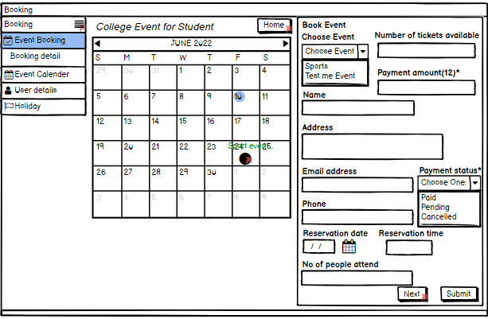**Booking**

1. This page displays the information required by user to conduct booking depends on type of event. Information such as name of the user, address of event, email address, phone number, reservation date, reservation time, no of people attend the plan event number of tickets available, price per person and payment status.
2. To book event, user will must select the event (from the added event). Once selected the appropriate event, user must enter the number of tickets available. The system will automatically display the amount of tickets available for that event. Example, if user select sports event the number of tickets will display 5 tickets. User must enter the amount required for that amount.
3. User will then enter their information detail for event. For payment status, user can set it paid, pending or cancelled. Once payment is made by all members (attend the event), the system will then display the paid status. If majority of members did not finish/complete the payment, the system will display the pending status until all payment has been made. If member want to choose a different event, they can choose to cancel the payment to prevent it from proceeding. If user accidentally make the payment but wanted to cancel the event, they must inform the club organizer to cancel the payment.
4. All the information will then display on event calendar based on chosen date. Upcoming feature will be set based on chosen event so if user want to feature it ON/OFF they must go to manage event page. It will the display the status of the event as upcoming in the event calendar.
5. As for holiday, the event calendar will display the all-public holiday in Malaysia. When user set booking on public holiday, it doesn't affect the planning of event.

Question (Event & Booking):

1. What are types of events can user implement in the system? Does it count any events that organised by university/college?
2. How can user view/ state their booking information in the system? What input should the user make to view their booking information?
3. What are majority of members does each event cover? Can it include any members such as parents, club organizer, students, lecturer and college administrative to attend the event?
4. What kind of information can the user input to provide an overall statement of event in event description?
5. After user conduct a full entry of information in event or booking, in what way can the system display the correct information to prevent confusion or system error?
6. How can the reset button automatically change all the information in system to an empty blank word?
7. Upon choosing the event, how does the system display the number of tickets available for each event? Does every event chosen show a different/similar number of tickets in system?
8. How does the booking information in system inform the user of their events by date and time? Does it send the information through email/phone notification/calendar?
9. How can the user mark the event as upcoming/past event? Does the system automatically mark the event as upcoming without informing the user or the information will directly tell the user that booking for event is set?
10. How can the system allow user to save their booking info upon conducting booking? Can user recover their booking info if accidentally deleted the info by mistake?

Link:

<https://balsamiq.cloud/suv74m/pj91vt1>